Cottage Rental Information Booklet

Draft for Cottage Owners

Last Updated:

<Your Name Here>
Table of Contents

1 Emergency Telephone Numbers 3
2 House Rules 4
2.1 Dogs 4
2.2 Wildlife 4
3 Garbage Disposal 5
3.1 Dump Hours (last updated Feb 2014) 5
4 Septic 5
5 Boats 6
5.1 Boat Launches/Marina 6
6 Municipal Fire Regulations 6
6.1 Boaters Code of Conduct 7

Emergency Telephone Numbers

<put your cottage address here> | <Put Your Cottage Telephone number here>
Emergency Numbers  Fire/Ambulance | 911
Police | 1 888 310 1122
Haliburton Hospital | 705 457 1392
Minden Hospital | 705 286 2285
Poison Information Centre | 1 800 268 9017
Telehealth (nursing info) | 1 866 797 0000
Haliburton Distress Centre | 705 457 3617
Hydro One (Electrical outages) | 1 800 434 1235
Fort Irwin Marina | (705)754-4176
Haliburton Outdoor | (705)754-9262
Haliburton Forest | (705)754-2198
Marine & Air Search Rescue | 1-800-267-7270

First Aid Kit

<advise where you keep your first aid kit>

Fire Extinguisher

<advise where you keep your fire extinguisher>

House Rules
We ask all renters to use common sense and consider safety. To ensure enjoyment of the lake for everyone the following house rules must be followed:

- No More than <X> people at any one time at the cottage
- No Outdoor music (ghetto blasters , stereos etc .)
- No Seadooing immediately in front of the cottage
- No harsh chemicals in the sinks or toilets (especially chlorine bleach)
- No camp fires
- Dogs may not be left to roam free
- Soap and Shampoo may never be used directly in the lake (including Biodegradable)
- No Fireworks

Dogs
The woods and forests around the cottage are inhabited by animals which could harm your dog/cat such as bears, porcupines, skunks and frogs. It's a good idea and just common sense to keep your dog close by at all times.

Please do not leave dogs to run freely,

- you poop and scoop, whether on our lot, on the beach, or any of the community roadways
- the dog is supervised and not left alone outside or left to bark. At night skunks, bears and raccoons are a country reality and can harm your pet.

Wildlife
Please do not feed the wildlife. There are black bears in cottage country. Just leave them alone, walk slowly away and above all DON’T FEED THEM.
Do not leave food on the deck or in the barbeque, raccoons and squirrels will make a real racket at night then leave a mess for you in the morning. Keep the barbeque cover closed when not in use and clean up any spilled grease.

Garbage Disposal
Garbage should be placed in the locked metal container. Do not leave garbage exposed outside, critters will have you cleaning it up. You must bring your garbage to the dump. Garbage left at the gate will result in fines and the dump attendant spot checks the contents – don’t leave garbage at the gate and do recycle.

Haliburton Lake West Bay dump is located on Haliburton Lake road...see map.

Recycling is separated into 3 groups. Containers (glass, plastic), fibre (paper, cereal boxes) and corrugated cardboard. Place your recycling into clear plastic bags, dump the entire bag into the large bins at the dump.

Dump Hours (last updated Jan 2014)
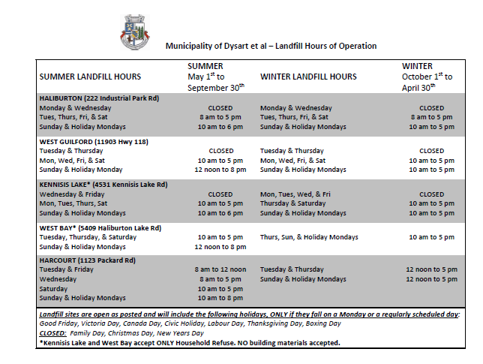
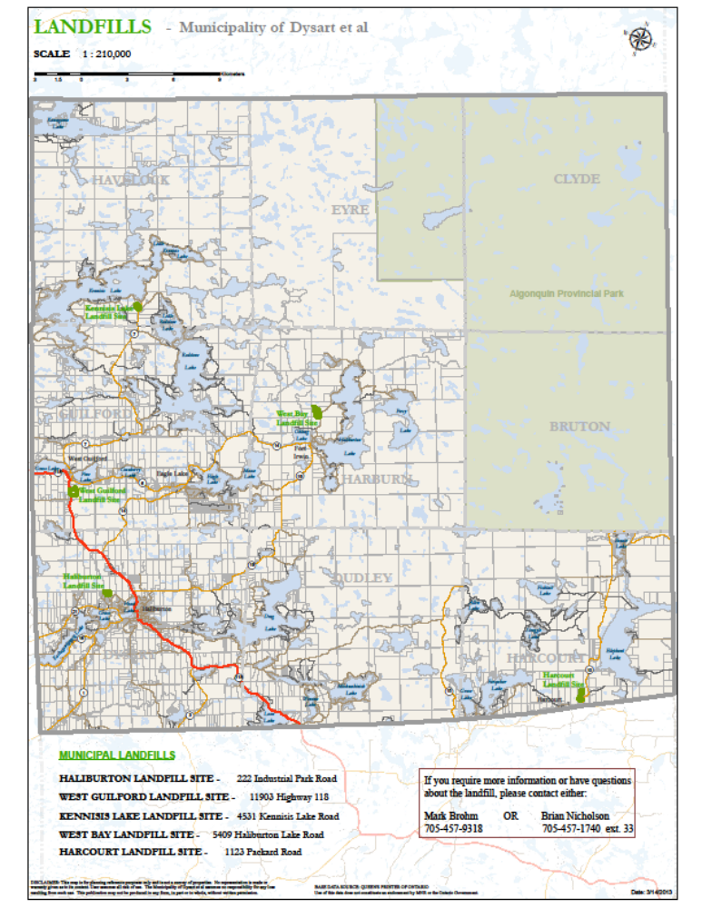

Septic
Sanitary napkins, diapers, paper towels, “pre moistened wipe ups”, grease, harsh cleaners, condoms or cigarette butts must never be put down the toilet. These items are sure to plug the system. If any restricted items are flushed down the toilet (or sinks), they will almost certainly cause plumbing problems.

Boats

Boat Launches/Marina

The Fort Irwin marina offers boat launch access to the lake. It costs $5.00 per use ($10.00 for in and out).

Please be advised that the OPP patrol the lake on a frequent basis and are commonly stopping boats on holiday weekends looking for alcohol or boaters without proper safety equipment / license.

It is strongly recommended that boaters observe hazard markers on all routes. Haliburton lake is dam controlled and rocks pop up as water levels drop.

Boaters Code of Conduct

All boaters are requested to adhere Boaters code of conduct:

Boaters Code of Conduct
‘Friendly Boating Practices on lakes within Haliburton County’

Follow the Safe Boating Guide and obtain your Pleasure Craft Operator’s Card– learn how to safely operate your boat.
Minimize your wake especially in narrow channels and near shore so that natural shorelines are not eroded, loon and duck nesting sites are not disturbed and neighbor’s floating docks and parked boats are not bounced around and damaged.
Reduce your speed especially in narrow channels and near shore where other boats and swimmers could be in danger and remember that within 30 meters of the shore your speed should be less than 10 km/hr (it’s the law).
Head for the centre of the lake when travelling at speed or when water skiing or tubing - don’t ride parallel to the shoreline.
Give everyone a wide berth and travel slowly when pulling away from docks, launching ramps or swimming areas.
Respect your neighbor’s TRANQUILITY by moving around the lake rather than operating on one small area.
Protect the environment by treating bays as no wake zones, operating in water over 1.2 meters (4 feet) deep to avoid disturbing the lake bottom, stowing garbage until you return to shore, and avoiding spillage of gas and oil into the water during refueling.
When anchored take care not to obstruct navigation for other boats.
Clean your boat and trailer when transporting them to other lakes and when bringing them into the Haliburton Lake to avoid transporting invasive species. Remember to drain your bilge on shore away from the lake and empty holding tanks for onboard toilets in a proper facility.

Remember that drinking and boating is dangerous and illegal.

Municipal Fire Regulations
Burning Regulations In Effect April 1 to October 31

No burning between two (2) hours after sunrise and two (2) hours before sunset
Fires must be attended at all times
Person in charge must be competent
Must have adequate equipment to extinguish fire
Person is responsible for any damages
Fire must be away from combustible material by at least three (3) meters
Pile not to exceed two (2) meters high

